Name : \_\_\_\_\_\_\_\_\_\_\_\_\_\_\_\_\_\_\_\_\_\_\_\_

|  |  |
| --- | --- |
| EGC_Black | **Eastern Goldfields College**  ***Year 12 MATHEMATICS METHODS***  ***TEST 2 2017*** |

**CALCULATOR FREE**

**Total Marks: 30**

**Reading: 2 minutes Time Allowed: 30 minutes**

Question 1 [5 marks]

Part of the graph of  is shown in the diagrams below.

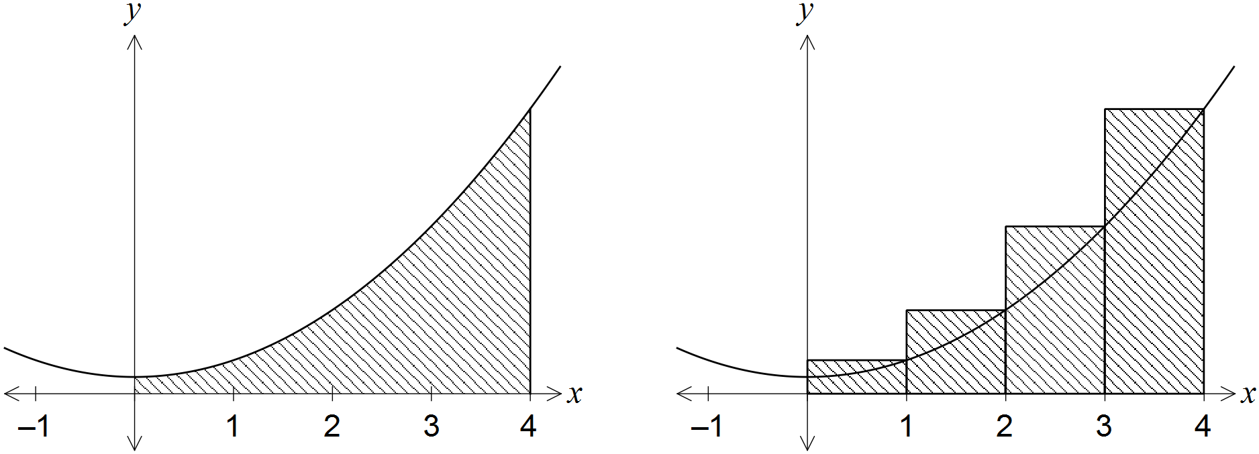

An approximation for the area beneath the curve between  and  is made using rectangles as shown in the right-hand diagram. Determine the exact amount by which the approximate area exceeds the exact area.

Question 2 [ 2, 2, 2, 2 – 8 marks]

Find and simplify the following.

1.  b) 

c)  d) dx

**Question 3 [ 3 marks]**

1. Find as an exact value the definite integral 

**Question 4 [ 4 marks]**

Find 

**Question 5 [ 1, 1, 2 - 4 marks]**

Part of the graph of 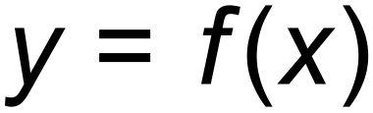 is shown below. The areas of regions A and B, bounded by the curve and the *x* – axis, are 11 and 2 square units respectively.

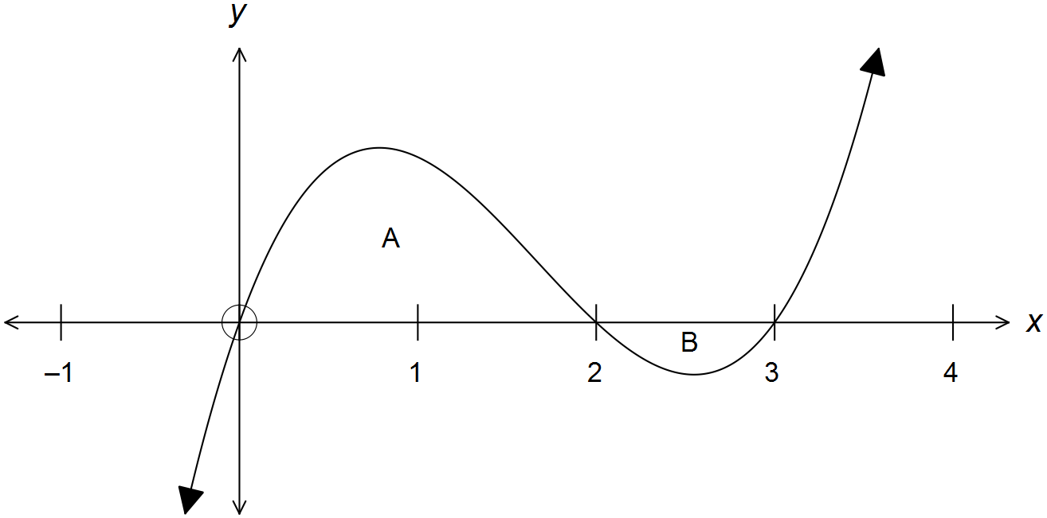

Evaluate:

(a) 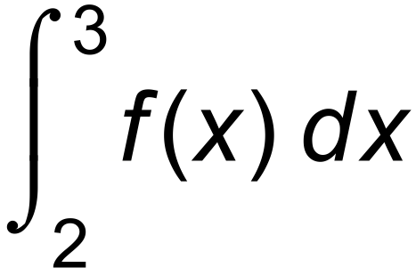

(b) 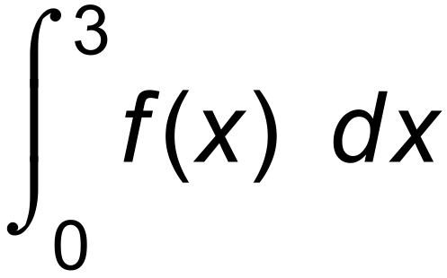

(c) 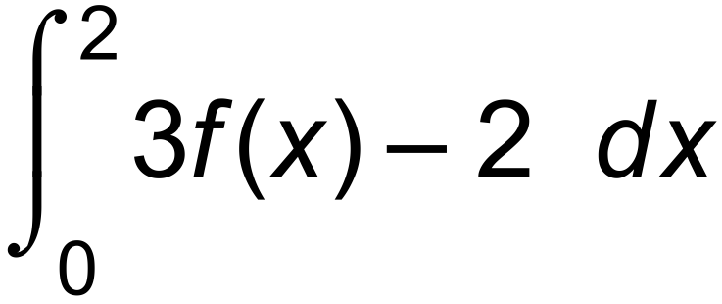

**Question 6 [ 2 marks]**

Determine  **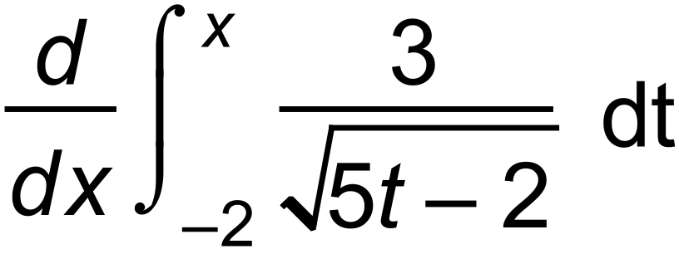**

**Question 7 [ 4 marks]**

The curve of the function 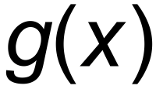 has a stationary point at (4, 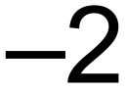) and a gradient function of 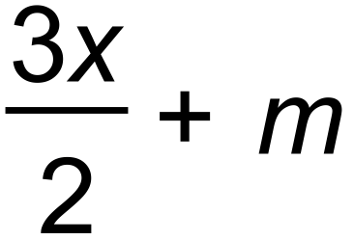 where m is a constant. Show that 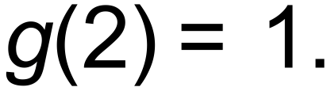

Name : \_\_\_\_\_\_\_\_\_\_\_\_\_\_\_\_\_\_\_\_\_\_\_\_

|  |  |
| --- | --- |
| EGC_Black | **Eastern Goldfields College**  ***Year 12 MATHEMATICS METHODS***  ***TEST 2 2017*** |

**CALCULATOR ASSUMED**

**Total Marks: 35**

**Reading: 2 minutes Time Allowed: 35 minutes**

**Question 8 [2, 2, 2 - 6 marks]**

The height of a tree is increasing at a rate of  metres per month where = 

1. Find the increase in height of the tree in the 5th month.
2. Find the average growth in the tree in the first 5 months.

The initial height of the tree was 2 metres.

1. Find the height of the tree after 2 years.

**Question 9 [1, 2, 2 - 5 marks]**

The graph below shows two shaded areas. A is the area bounded by the curve 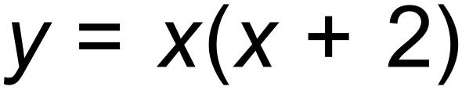 and the

line *y* = . B is the area between the curve , the line *y* =  and

the line *x* = *p*.

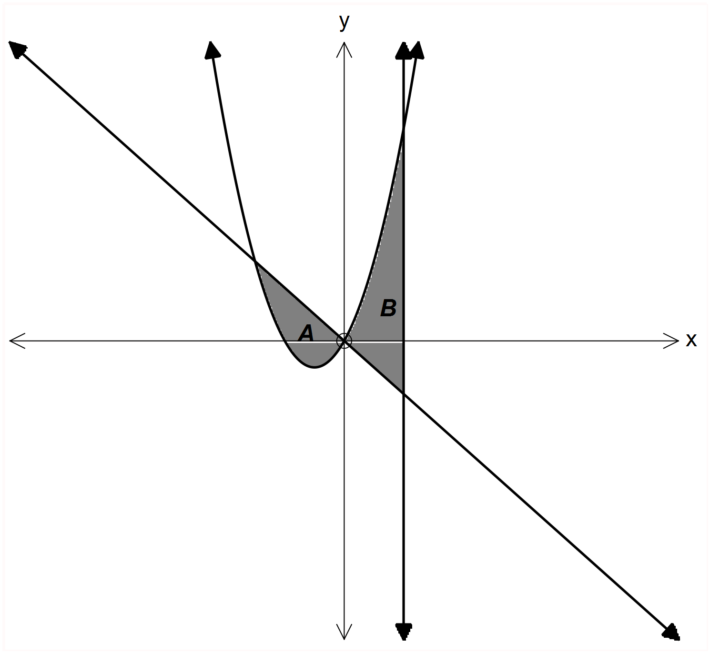

(a) Determine the area of A.

(b) Write down an integral that when evaluated will determine the area of B.

(c) Find the value of *p* so that area B is 9 units, giving your answer correct to 3 decimal places.

**Question 10 [2, 2, 2 - 6 marks]**

A particle P travels in a straight line. Its acceleration is given by 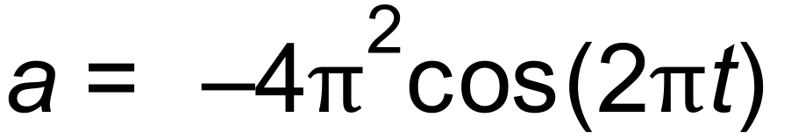 ms–2. The initial velocity of P is 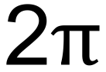 ms–1. Calculate

(a)the velocity of P when 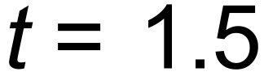 seconds.

(b) the change in displacement in P in the first 1.5 seconds.

(c) the distance travelled by P in the first 1.5 seconds.

**Question 11 [ 1, 1, 2, 3, 2, 2, 2, 5 - 18 marks]**

A particle moving in rectilinear motion has its velocity function graphed below, where *t* is time in seconds and

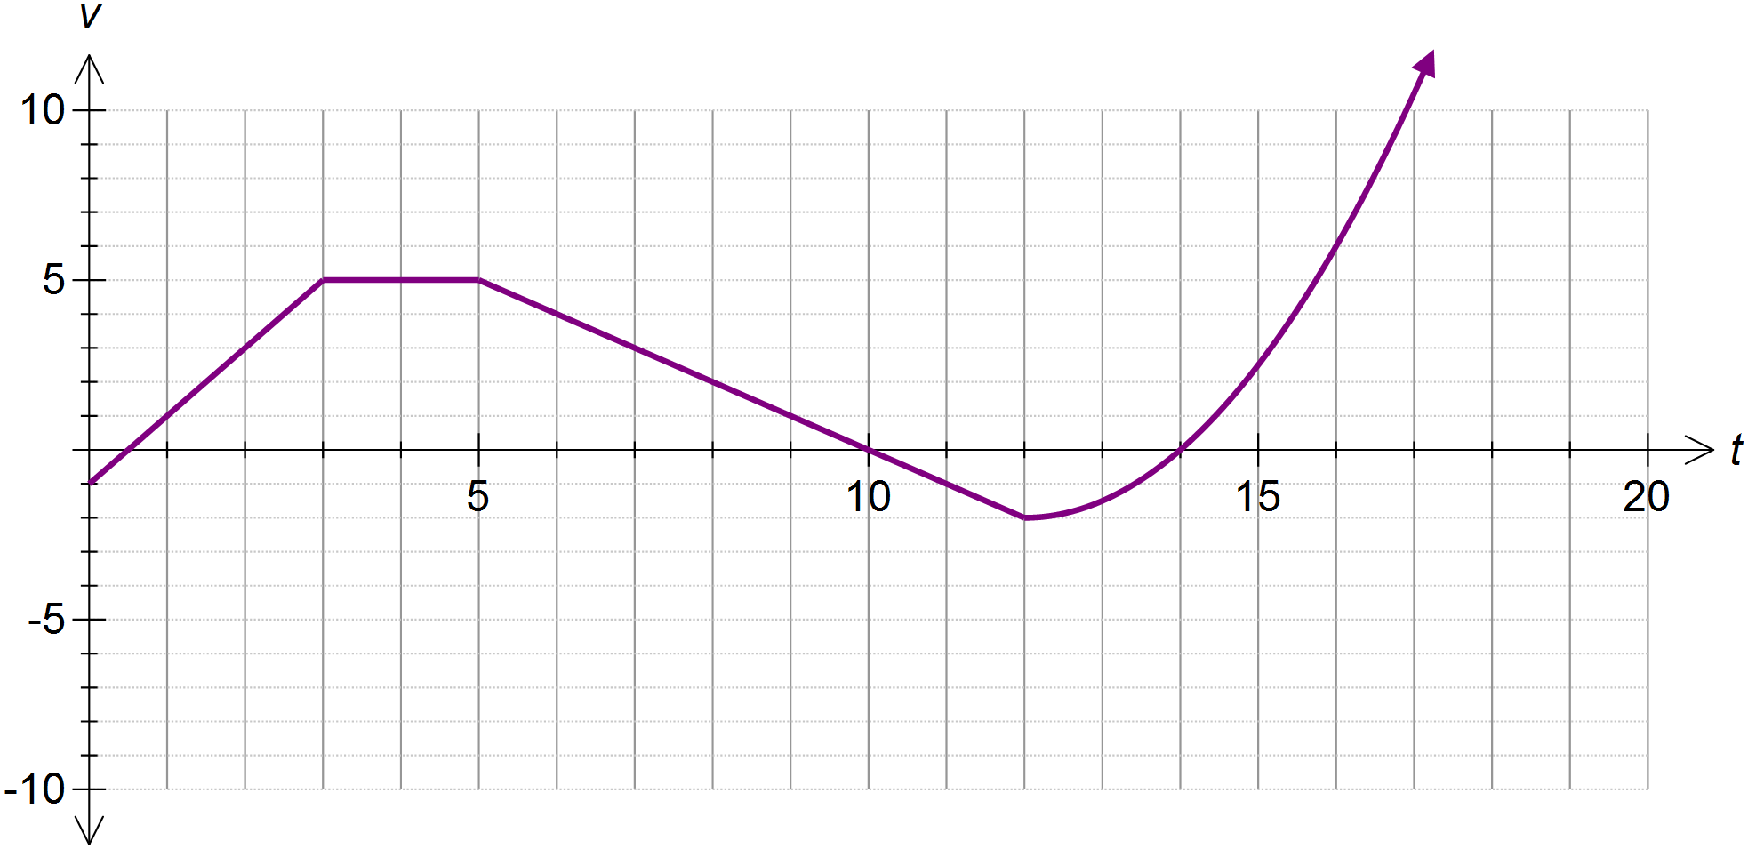

*v* is in ms-1.

(a) Determine the initial speed of the particle.

(b) Determine the acceleration of the particle during the 4th second.

(c) Calculate the displacement of the particle after 3 seconds.

(d) Calculate the distance travelled by the particle in the first 12 seconds.

(e) Determine when the particle has travelled a distance of 21 m since commencement.

(f) State the times when the particle was at rest.

(g) When did the particle first return to the origin?

(h) Calculate the distance travelled by the particle for  if it is known that the velocity for is given by .